16.1.1 Editors - Timeline - Header Tools and Options
Introduction 2
Playback Elements 2
Jump to Endpoint - start 2
Jump to Keyframe - previous 2
Play Animation - backward 2
Play Animation - forward 2
Jump to Keyframe - next 2
Jump to Endpoint - end 2
Current Frame 2
Use Preview Range 2
Start 3
End 3
Insert Keyframe 3
Delete active keying set keyframe 3
Active Keying Set 3
Auto Keying 3
Active Keying Set 3
Playback Panel 4
Sync Mode 4
No Sync 4
Frame Dropping 4
AV Sync 4
Audio Scrubbing 4
Mute Audio 4
Sub frames 4
Limit Playback to Frame Range 4
Follow Current Frame 4
Play Animation in ... 4
Set Start Frame, Set End Frame 4
Keying Panel 5
New Keyframe Type 5
Auto Keyframing 5
Auto Keying Mode 5
Auto Keyframe Insert Keying Set 5
Layered Recording 5
Cycle Aware Keying 5

Introduction

The header contains various menus and tools. This chapter here is about the tools and options elements in the header.

The text menus are covered in an own chapter each.

Playback Elements

The playback elements allows you to play your animation, and set the animation range.

Jump to Endpoint - start
Jumps to the first frame.

Jump to Keyframe - previous
Jumps to the keyframe before the current position.

Play Animation - backward
Plays the animation in reverse direction.

Play Animation - forward
Plays the animation.

Jump to Keyframe - next
Jumps to the keyframe after the current position.

Jump to Endpoint - end
Jumps to the last frame.

Current Frame
The edit box with the position of the current frame. Click at the value and type in another value to jump to another frame.

Use Preview Range
Toggle an alternative range used to preview animations. The Preview range works for the UI playback, but will not work for rendering an animation.
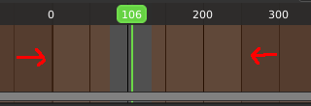
The preview range is displayed in orange color. The original playback range that is used for rendering is still displayed in grey underneath. When Use Preview Range is on, then the animation will loop between the Preview range.

Start
The start frame for the animation in current mode.

End
The end frame for the animation in current mode.

Insert Keyframe
Inserts a keyframe. You need to have a keying set assigned already. See Active Keying Set drop down box.

Delete active keying set keyframe
Removes the keyframe at the current position in the current active keying set.

Active Keying Set
Objects needs a so called keying set so that you can record animation for it. It is a container for the animation, a set of keyframe channels. When you try to record an animation without an existing keying set, then you will get a warning since the channels for the keyframes are missing.

In this property you can choose a method from the builtin keying sets.

Auto Keying
With auto keying on every manipulation in the 3d view will automatically create a keyframe, or update the existing keyframe at the current position.
Note that Auto Keying just works with transform properties ( Objects and Bones) in the 3d View. It will not work to animate colors in the Properties Editor for example.

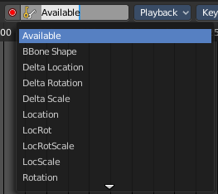
Active Keying Set
Choose your keying set.

Playback Panel

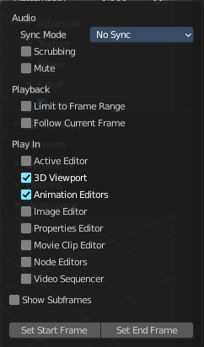
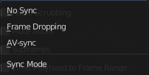
Here you can find various options for playback.

Sync Mode
How to synchronize playback.

No Sync
Don't synchronize. Play every frame.

Frame Dropping
Drop frames if playback is too slow.

AV Sync
Drop frames to synchronize to Audio Playback.

Audio Scrubbing
Play existing audio from sequence editor when scrubbing.

Mute Audio
Mute existing audio from sequence editor.

Sub frames
Show current scene sub frame and allow to set it by using interface tools.

Limit Playback to Frame Range
Don't allow frame selection with the mouse outside of the play range.

Follow Current Frame
Follow current frame in editors.

Play Animation in ...
Plays the animation in the chosen editor types.

Set Start Frame, Set End Frame
Sets the current frame position as the start frame / the end frame.

Keying Panel

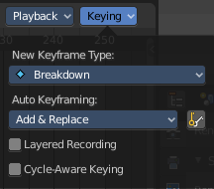
Some more keying options.

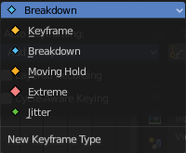
New Keyframe Type
Recolor the currently selected keyframes. Or create the next keyframe with this chosen keyframe color.

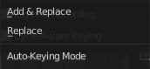
Auto Keyframing

Auto Keying Mode
Just replace existing keyframes, or add keyframes too.

Auto Keyframe Insert Keying Set
Automatic Keyframe Insertion using the active keying set only.

Layered Recording
Add a new NLA Track and Strip for every loop/ pass made over the animation to allow non destructive tweaking.

Cycle Aware Keying
For channels with cyclic extrapolation, keyframe insertion is automatically remapped inside the cycle time range, and keeps the ends in sync.

